Final Year B.Tech. (CSE) – VII [2024-25]

**6CS452: High Performance Computing Lab**

Assignment No: 6

# Date: 12/08/2024

**Implementation of OpenMP programs**

**PRN:** 21510017  **Name:** Onkar Anand Yemul

**Title:** Implementation of OpenMP programs

Implement following Programs using OpenMP with C:

1. Implementation of Matrix-Matrix Multiplication.
2. Implementation of Matrix-vector Multiplication.

**Problem Statement 1: Implementation of Matrix-Matrix Multiplication**

**Screenshots:**

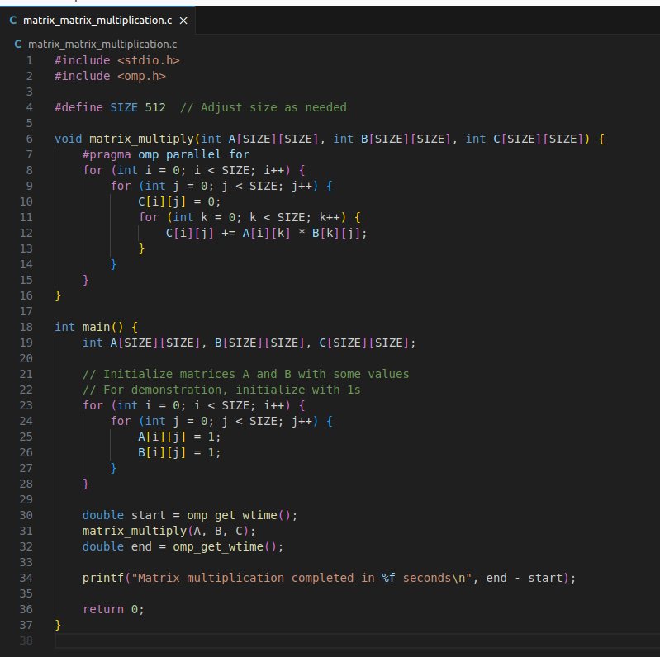

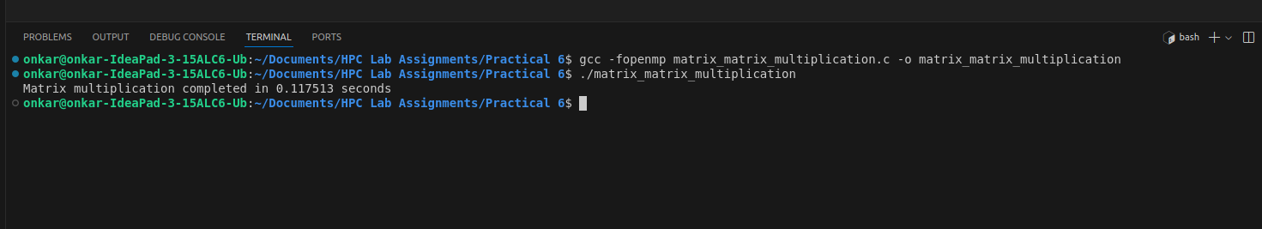

Information:

* This program multiplies two matrices A and B, and stores the result in matrix C.
* The #pragma omp parallel for directive is used to parallelize the outer loop to utilize multiple threads.

Analysis:

* Analyze the performance by varying the matrix size and number of threads.
* Observe the impact on execution time and discuss the scalability and efficiency.

**Problem Statement 2: Implementation of Matrix-Vector Multiplication**

**Screenshots:**

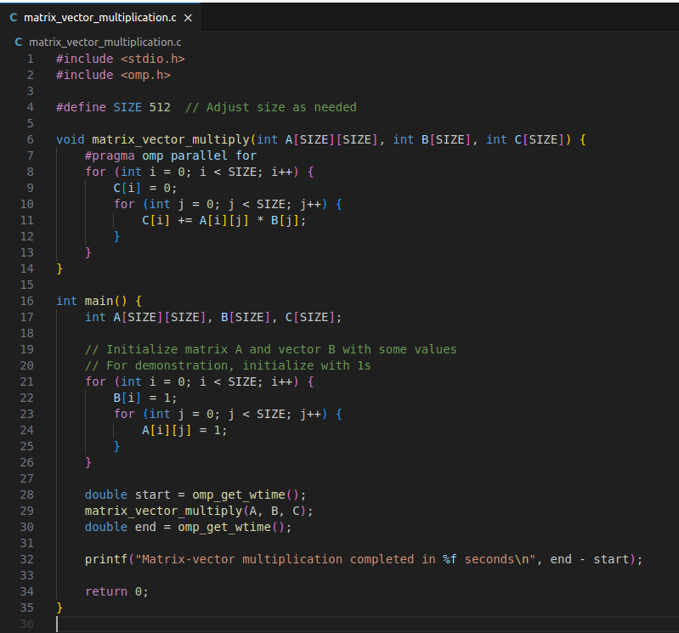

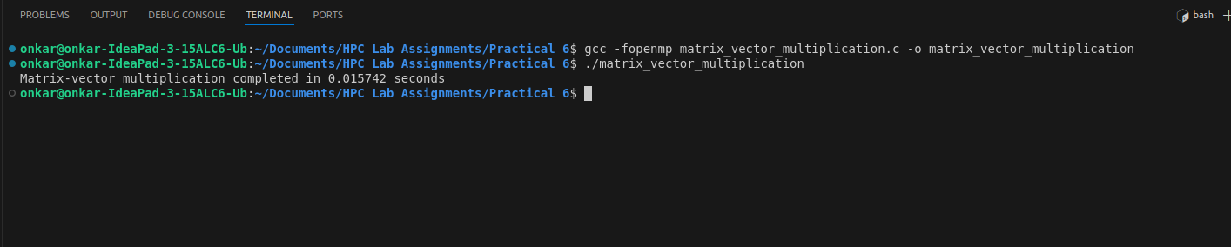

Information:

* This program multiplies a matrix A with a vector B and stores the result in vector C.
* The #pragma omp parallel for directive is used to parallelize the computation of each element in vector C.

Analysis:

* Analyze the performance by varying the vector size and number of threads.
* Compare the execution times and discuss the efficiency and scalability of the matrix-vector multiplication.

**Github Link:**

<https://github.com/onkaryemul/HPC-LAB-Assignments/tree/main/Practical%206>